- Screen: Doctor
- Doctor screen patient profile not showing his patients (current and past)
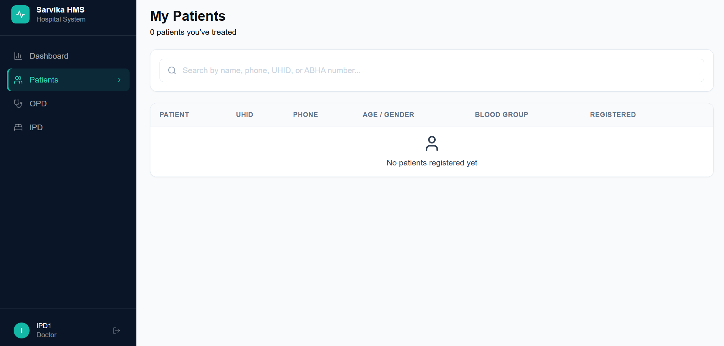
- Screen: Cashier
- Cashier should not be able to see bed grid in the IPD page
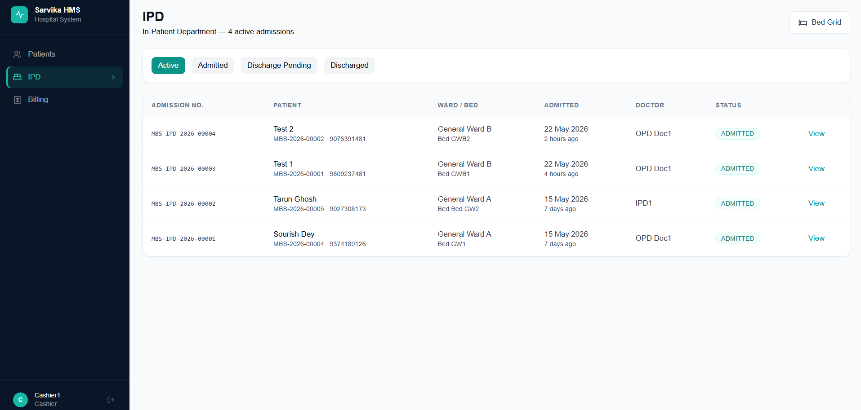
- Cashier should not see “Vitals” & “Nurse notes” in the patient profile of a IPD patient (refer below screenshot)
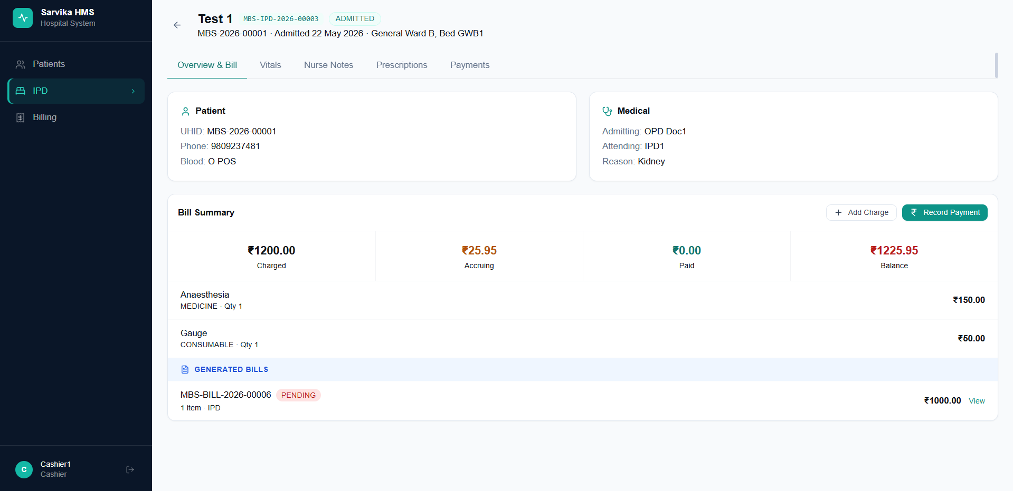
- In the billing page the stat “Balance Due” should show total outstanding balance for the hospital till date
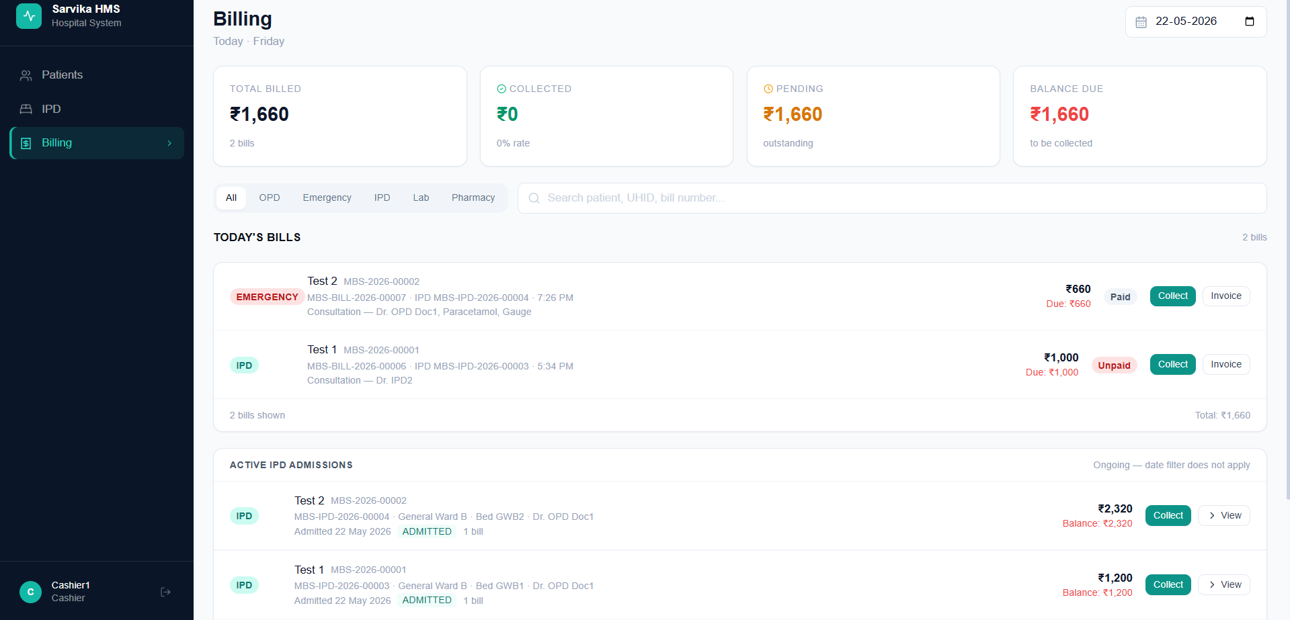
- In “Add Charge” – only “Other” and “Procedure” – should be free text type not dropdown
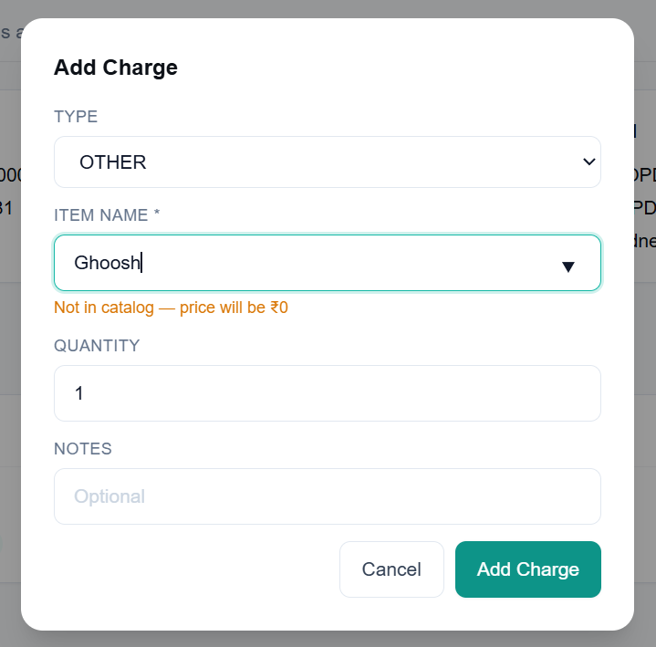

- Must modifications:
- In patients page – once a patient has been discharged from IPD Admission – the IPD visit history is not being shown in the patient profile under IPD (please refer to the below screenshot)
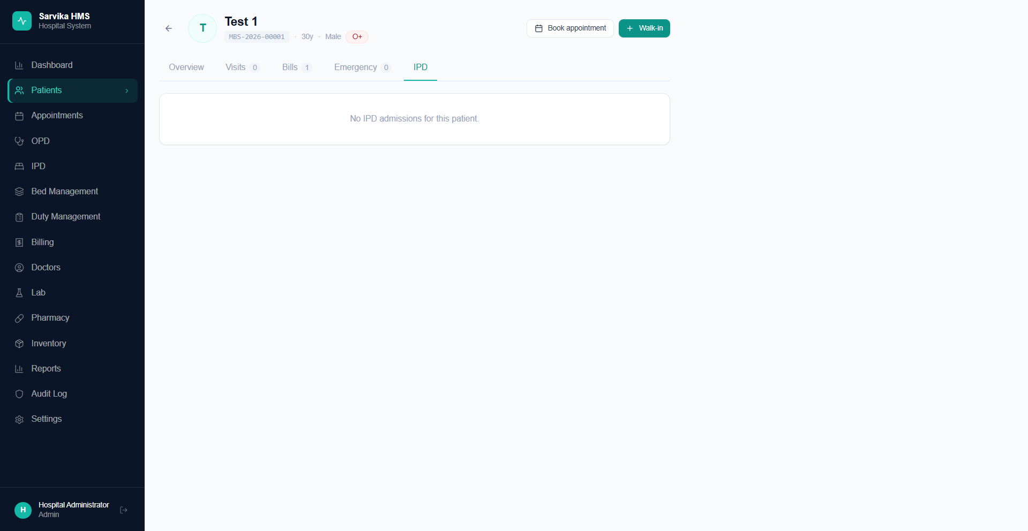
- Even after discharging the patient with final settlement from the cashier, the Bill in the patient profile is being shown as partial. I think this happened because I recorded the payment from the “IPD Patient Profile” and not the billing page – maybe this can be the reason (please refer to the below screenshots). The record payment button in the IPD patient profile page should actually open the record payment box which opens from the billing page.
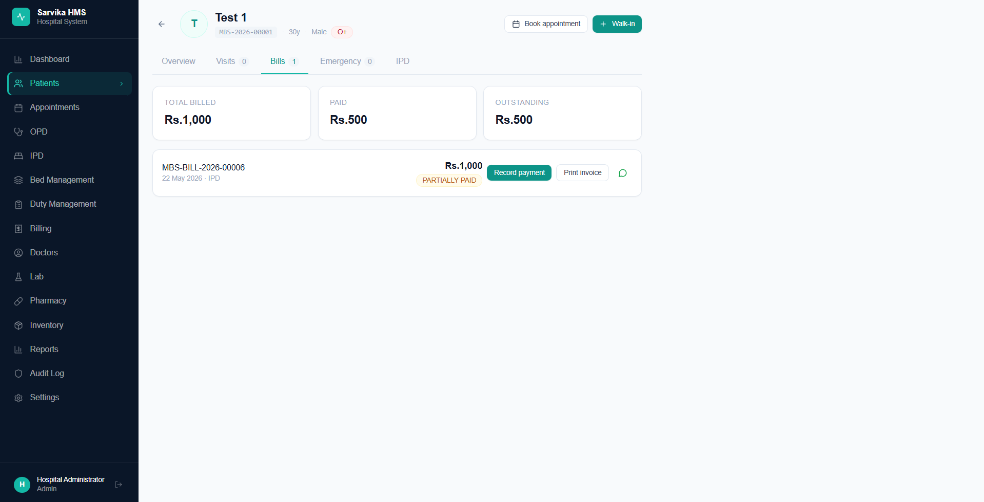
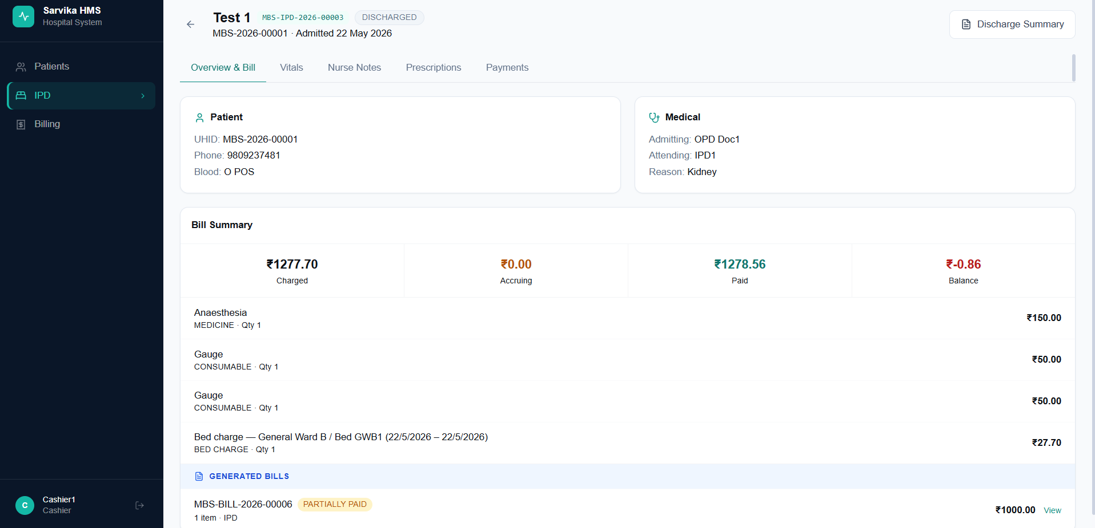
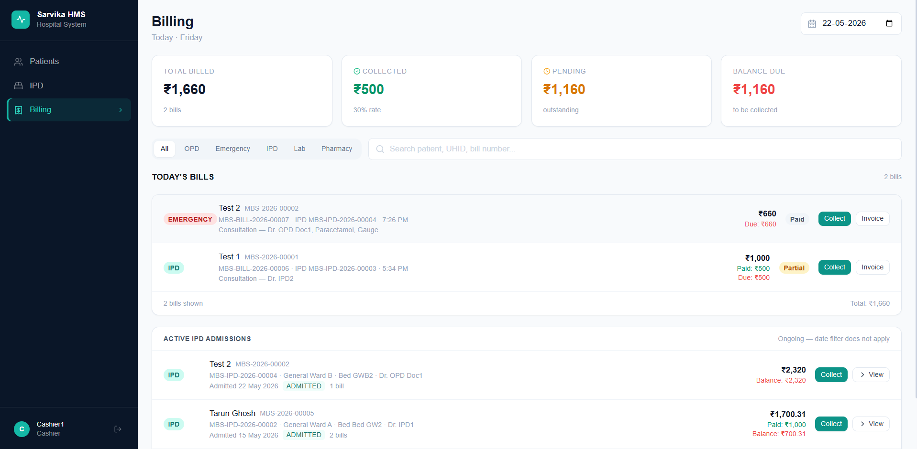
- Once a doctor initiates a discharge the bed accruing charges should stop accruing at that point.

